**CICD EXPERIMENT – 9**

**Uploading artifacts on Nexus server using Command Line**

1. Visit **sonatype.com/nexus/repository-oss/download** to download nexus server

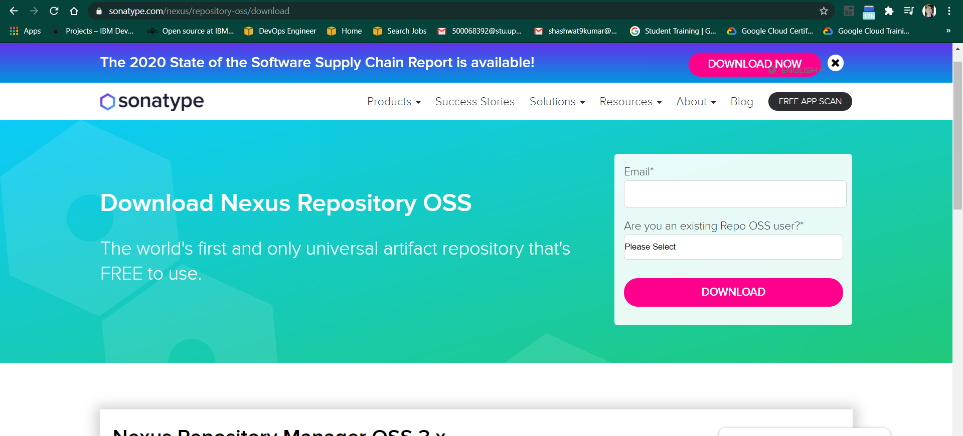

1. Go to the location where Nexus is installed in your machine and open the bin folder. Find “nexus.exe” file and copy its path
2. Open command prompt and change directory to the copied path and run “nexus.exe /run” command

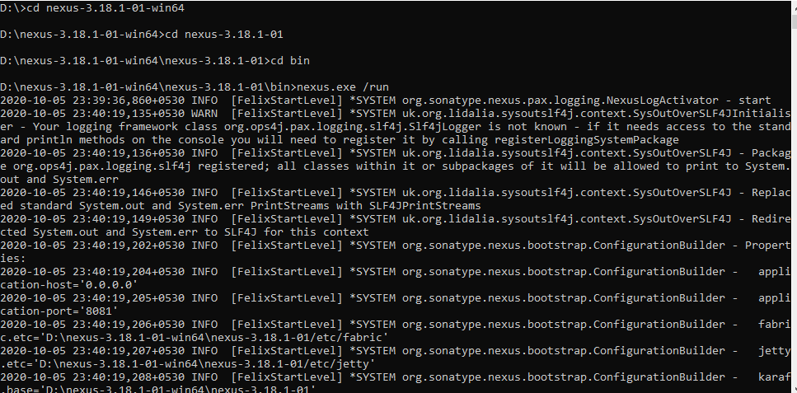

1. Once the command runs, open localhost:8081 in your browser

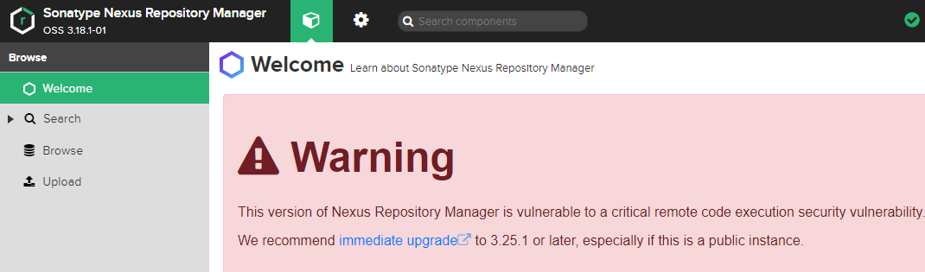

1. In Repositories section, Create a new repository(here “Nexus_CICD”) and copy its URL

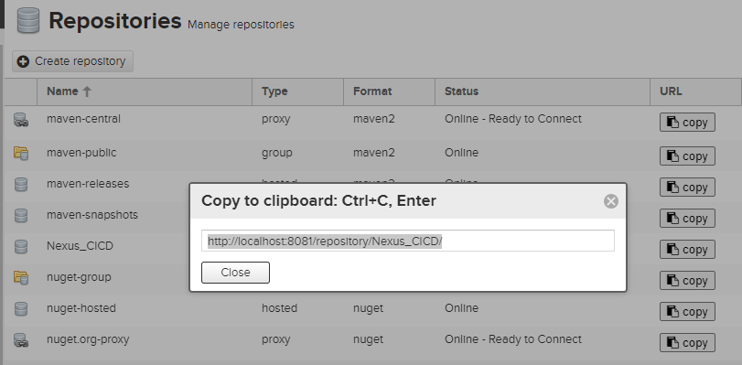

1. Now open “settings.xml” file in the “apache-maven-3.6.3” folder and add the tag “server” with the required commands

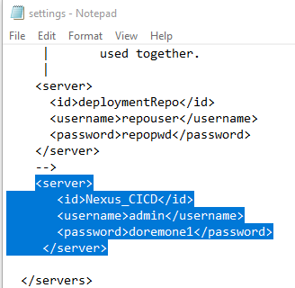

1. Now open the “pom.xml” file of the Maven project to be published to Nexus server. Add the “snapshotRepository” tag into pom.xml file and give URL of Nexus Repository copied

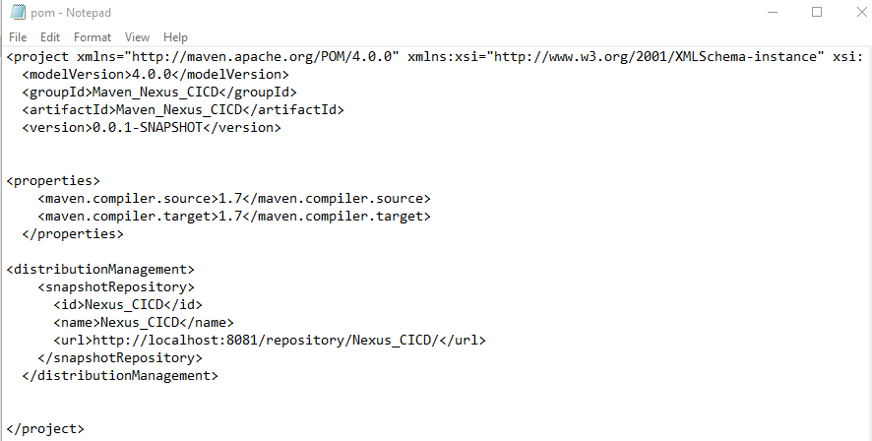

1. Now open command prompt and run “mvn clean”, “mvn install” command to check the working of the maven project

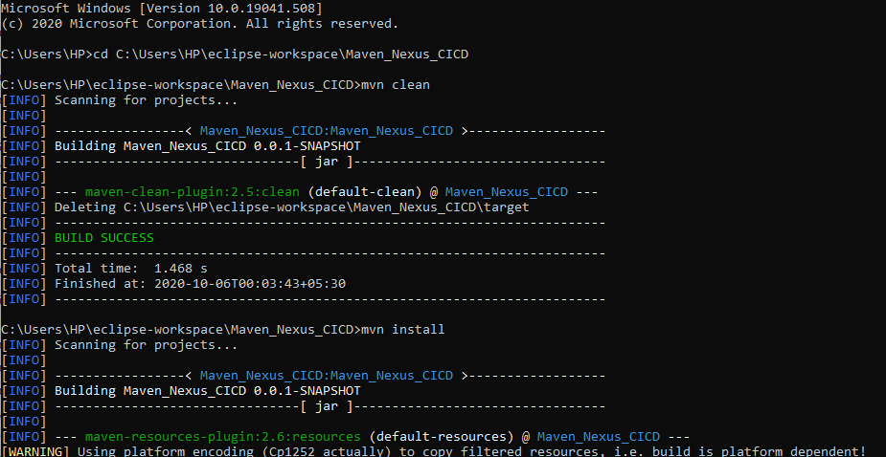

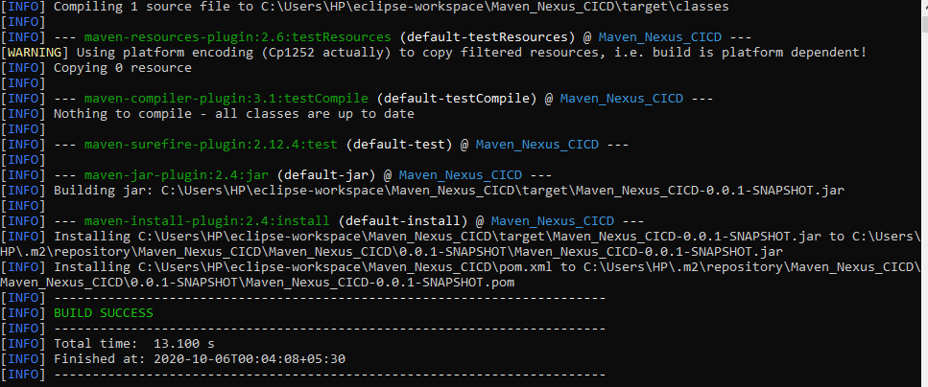

1. Now run “mvn deploy” command to deploy the build jar on Nexus server

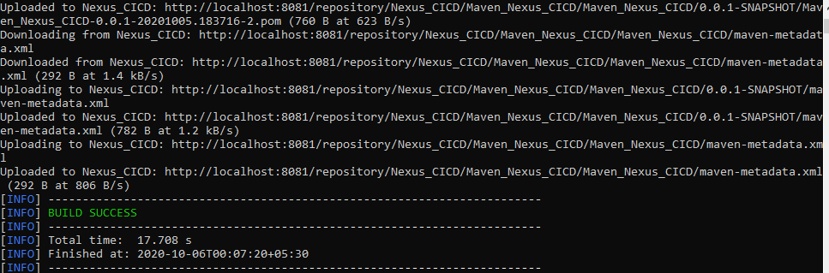

1. Browse the Nexus repository to see the deployed jar file

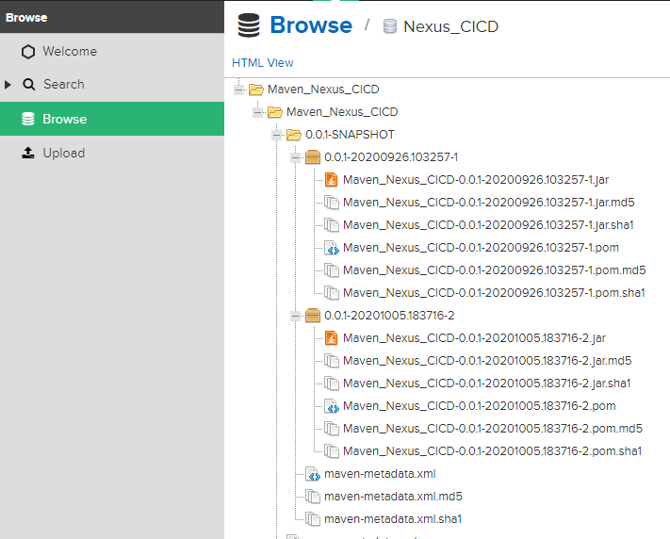

ATISHAY JAIN

500067694

R171218030

CSE, DEVOPS